Anantha Lakshmi Institute of Technology and Sciences (ALITS)
Department of Data Science

Visualizing Housing Market Trends: An Analysis of Sale Prices and Features using Tableau
Ideation Phase — Empathy Map Canvas

Project Name: Housing Market Trends using Tableau
Team ID: ALITS-DS-2026-HousingMarketTrends
Academic Year: 2026

Empathy Map Canvas
The Empathy Map helps the team step into the shoes of the primary user — a prospective home buyer / real-estate analyst — to better understand their thoughts, feelings, environment, and behavior before designing the Tableau dashboard solution.
User Persona
Attribute | Details
Persona Name | Ramesh — Prospective Home Buyer
Age Group | 28–45 years
Role | Working professional planning to purchase a home
Goal | Find a fairly priced home that matches budget and requirements

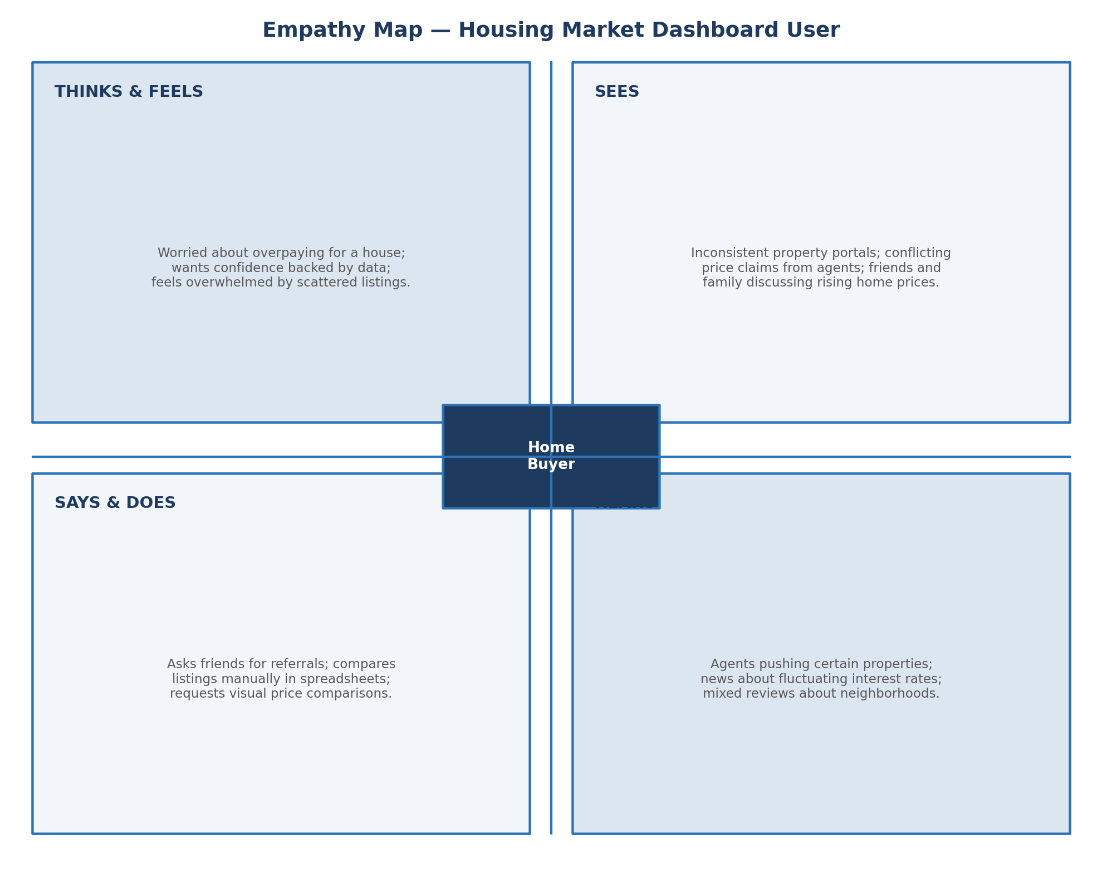
Figure 1.1: Empathy Map Canvas — Housing Market Dashboard User
Detailed Quadrant Analysis
Think & Feel
- Worried about overpaying for a property compared to its actual market value.
- Wants confidence that a purchase decision is backed by real data, not just agent opinion.
- Feels overwhelmed comparing dozens of listings manually.
See
- Inconsistent pricing information across different property portals.
- Friends and family members reacting to rising or falling home prices.
- Agents presenting selective, favorable comparisons.
Say & Do
- Asks friends and colleagues for referrals and price benchmarks.
- Manually copies listing data into spreadsheets to compare.
- Requests visual, side-by-side price comparisons from agents.
Hear
- Agents recommending specific properties for their own benefit.
- News reports about fluctuating interest rates and housing demand.
- Mixed reviews about neighborhoods and future value appreciation.
Pain Points
- No single, trustworthy, visual source to evaluate a property's price fairness.
- Difficult to see how renovation, age, or bathroom count affect price.
Gains / Needs
- An interactive dashboard that instantly filters and visualizes relevant price trends.
- Clear KPIs and storyboards that summarize the housing market at a glance.

